World War II Timeline Map Activity
Direction: Go to the Interactive WWII Timeline & Map & select “ENTER”. https://www.abmc.gov/sites/default/files/interactive/interactive_files/WW2/index.html You can either “View times as ‘Map’ or ‘Chart’”. Provide the date range, location(s), answer the questions, and in a sentence or two connect the video content to the specific event. Map each event on either the Ë (Europe) or Ŵ (World) map according to the predesignated year color.

Select “1939” (RED)
- Select “Germany Invades Poland”. Date Range: _________________ Location(s): _________________
Ë
  - Prior to the invasion, what did Germany do with the USSR?

  - What happened as a result of the German invasion of Poland on September 3rd, 1939?

  - What did the USSR do to eastern Poland?

    - Video Reflection:

Select “1940” (RED)
- Select “Battle of Flanders”. Date Range: ___________________ Location(s): ___________________
  - What were the first 9 months of war on the western front called?
Ë

  - What happened at Dunkirk?

    - Video Reflection:

- Select “Battle of France”. Date Range: ___________________ Location(s): ___________________
  - What was the outcome of the Battle of France (provide specific date too)?
Ë

  - What was the Vichy Government of south & east France?

    - Video Reflection:
- Select “Battle of Britain”. Date Range: ___________________ Location(s): ___________________
  - Who inspired the British people?
Ë

  - Why did Hitler want to destroy Britain’s Royal Air Force?

  - What advantages and disadvantages did Britain have? What outcome did this lead to?

    - Video Reflection:

- Select “Tripartite Pact”. Date Range: ___________________ Location(s): ___________________
  - What did this pact form and what did they become known as?
Ŵ
Ë

    - Video Reflection:

- Select “Lend-Lease”. Date Range: ___________________ Location(s): ___________________
  - What was America’s policy at the start of WWII and what Acts supported this policy?
Ŵ
Ë

  - Describe how “Lend-Lease” helped the Allies.

    - Video Reflection:

Select “1941” (ORANGE)
- Select “Germany Invades USSR”. Date Range: _________________ Location(s): _________________
Ë
  - Why did Hitler want to attack the USSR?

  - By what month was the German army “besieging Leningrad”.

    - Video Reflection:

- Select “United States Garrisons Iceland/Convoy…” Date Range: __________ Location(s): __________
Ë
  - What are convoys?

  - Why were convoys needed in the Atlantic?

    - Video Reflection:

- Select “Atlantic Charter”. Date Range: ___________________ Location(s): ___________________
Ë
  - What was the Atlantic Charter?

- Select “Star of David Badges”. Date Range: ___________________ Location(s): ___________________
  - What did Hitler do to Polish Jews?
Ë

  - Describe the purpose of the State of David Badge.

    - Video Reflection:

- Select “Japanese Attack Pearl Harbor”. Date Range: _______________ Location(s): _______________
  - What did America do in response to Japanese aggression in the Pacific?
Ŵ

  - Why did the Japanese attack the U.S. Navy at Pearl Harbor?

  - Was the surprise attack a complete success for Japan? Support you claim with evidence.

  - What did this attack lead to on the 8th of December? On the 11th of December?

- Select “Philippine Islands Campaign”. Date Range: ________________ Location(s): ________________
  - What side seemed to have the advantage from the beginning?
Ŵ

  - Describe the conditions of the Filipino-American forces on the Bataan Peninsula.

    - Video Reflection:

Select “1942” (YELLOW)
- Select “Air Offensive, Japan”. Date Range: ___________________ Location(s): ___________________
  - What did Lieutenant colonel Doolittle command in April, 1942?
Ŵ

  - What was the impact of this operation?

  - What other types of bombings did the Allies resort to in February, 1945 and August, 1945?

    - Video Reflection:

- Select “Battle of Midway”. Date Range: ___________________ Location(s): ___________________
  - What did the Americans “break” that gave them a strategic advantage?
Ŵ

  - Who won this battle? Use evidence to support your claim.

    - Video Reflection:

- Select “Air Offensive, Europe”. Date Range: __________________ Location(s): __________________
  - What German targets did the allies strategically bomb?
Ë

  - How frequent were the bombing runs on Germany?

  - What impact did this offensive have on Germany?

    - Video Reflection:

- Select “Guadalcanal Campaign”. Date Range: _________________ Location(s): _________________
  - Why did the Japanese attack the Solomon Islands (Guadalcanal is one of the islands)?
Ŵ

  - What were conditions like on the islands for both sides?

  - Who eventually won this campaign?

    - Video Reflection:

- Select “Battle of Stalingrad”. Date Range: ___________________ Location(s): ___________________
  - Describe the type of fighting used in this battle.
Ë

  - How many troops did Hitler lose in this battle?

    - Video Reflection:

- Select “Manhattan Project”. Date Range: ___________________ Location(s): ___________________
  - What happened in 1939 that encouraged the Manhattan Project?
Ŵ

  - What was the Manhattan Project?

  - Who ironically helped develop the atomic bomb?

  - When and where was the first successful man-made nuclear explosion?

    - Video Reflection:

- Select “Tunisian Campaign”. Date Range: ___________________ Location(s): ___________________
  - Who eventually won this campaign in North Africa?
Ŵ

  - What impact did this and the Battle of Stalingrad have on Germany?

    - Video Reflection:

Select “1943” (GREEN)
- Select “Sicily Campaign”. Date Range: ___________________ Location(s): ___________________
Ë
  - Why did Allies want to invade Sicily?

  - What happened on July 25th?

    - Video Reflection:

- Select “Tehran Conference”. Date Range: ___________________ Location(s): ___________________
Ŵ
  - Who did this bring together for the first time?

  - Why did they meet?

  - What was the name of this operation? Why was it so important?

  - What did the USSR promise to do AFTER the potential defeat of Germany?

  - What organization was proposed?

    - Video Reflection:

Select “1944” (BLUE)
- Select “Normandy Campaign”. Date Range: __________________ Location(s): __________________
- What was the name of the French Invasion plan?
Ë

- How many troops were built up in the British Islands for this invasion?

- Video Reflection:

- Select “Leyte Campaign”. Date Range: ___________________ Location(s): ___________________
- Why did the allies want Leyte?
Ŵ

- What effect did this campaign have on the Japanese?

- Video Reflection:

Select “1945” (VIOLET)
- Select “Yalta Conference”. Date Range: ___________________ Location(s): ___________________
  - Who met at the Yalta Conference and why?
Ë

  - What Conference commitment did Stalin later “Renege” on (back out of)?

  - What positives and negatives came out of this meeting?

    - Video Reflection:

- Select “Iwo Jima”. Date Range: ___________________ Location(s): ___________________
  - Why was capturing Iwo Jima important to the Allies?
Ŵ

  - What was the fighting like on Iwo Jima? Who eventually won?

  - What iconic image comes from this battle?

    - Video Reflection:

- Select “Southern Philippines Campaign”. Date Range: ______________ Location(s): ______________
  - Who conducted operations to liberate the Philippines?
Ŵ

  - What type of terrain was most of the fighting occurring in and what type of warfare was used?

  - Who eventually won?

    - Video Reflection:

- Select “Central Europe Campaign”. Date Range: _________________ Location(s): _________________
  - Compare the military numbers Allies vs. Germans.
Ë

  - Who was leading the allied invasion and what did he decide about the invasion of Berlin?

  - What happened on April 30th? Why?

    - Video Reflection:

- Select “German Surrender”. Date Range: ___________________ Location(s): ___________________
  - What happened to Benito Mussolini?
Ë

  - What happened on May 8th? What was this day called? What does this stand for?

    - Video Reflection:

- Select “Potsdam Conference”. Date Range: ___________________ Location(s): ___________________
  - Who met at this conference? What had changed about U.S. leadership? When did this happen?
Ë

  - What happened to Germany as a result of this and the Yalta Conference?

  - What was the Potsdam Declaration?

    - Video Reflection:

- Select “Hiroshima”. Date Range: ___________________ Location(s): ___________________
  - What did the Japanese do in regards to the Potsdam Declaration? What was the U.S. response?
Ŵ

  - What was the human cost of the bombing of Hiroshima?

  - What happened three days later on August 9th?

    - Video Reflection:

- Select “Japanese Surrender”. Date Range: ___________________ Location(s): ___________________
  - When did Japan surrender officially, announce their surrender, and then formally surrender on the USS Missouri?
Ŵ

    - Video Reflection:

- Select “Nuremberg Trials”. Date Range: ___________________ Location(s): ___________________
  - What was the International Military Tribunal?
Ë

  - What were these trials about?

  - What was the verdict for the major war criminals?

  - Which German leaders committed suicide before the war ended? Why?

  - What impact did the Nuremberg Trials have for future conflicts and issues?

    - Video Reflection:

Ë
Europe Map
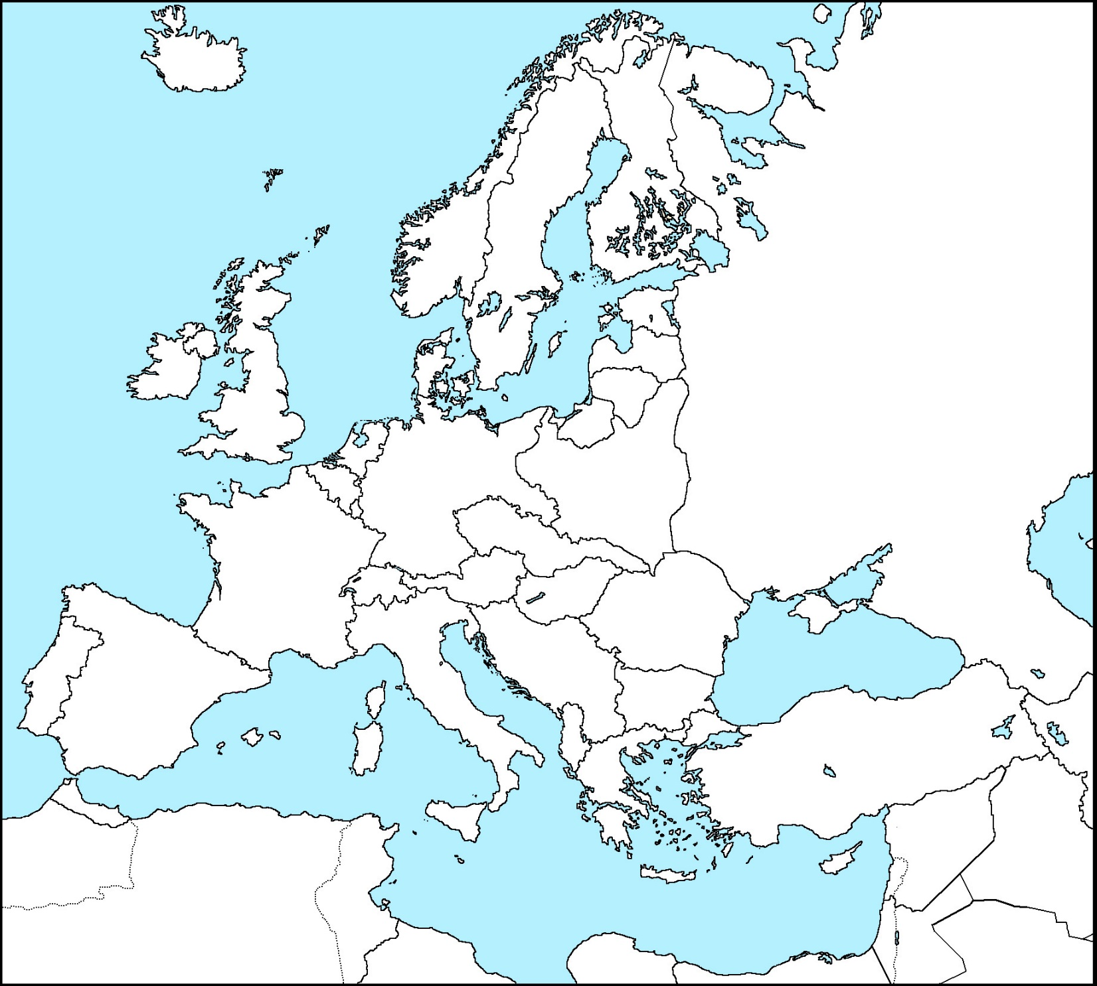
Map and label events in the appropriate year color.
1939-1940
1941
1942
1943
1944
1945
Ŵ
World Map
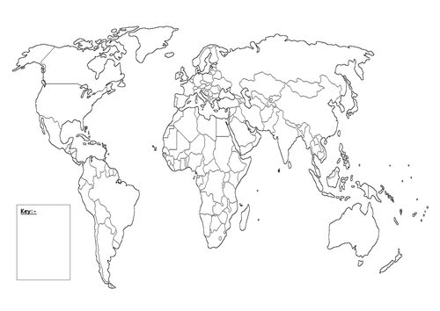
1939-1940
1941
1942
1943
1944
1945

Extra Credit Extension
https://www.abmc.gov/sites/default/files/interactive/interactive_files/WW2/index.html
Select one of the following interactive pages to go in depth on an aspect of American involvement in WWII. Write a one page (MINIMUM) paper answering the specific prompt of your choosing.

- Americans in Great Britain (1942-1945): Americans in Great Britain

  - Interactive site has…
    - Timeline & Text or Videos @ bottom when tabs are selected.
    - Briefing Text & Vocabulary @ bottom connected to Timeline.
    - Interactive Map showing military positions and events (Background)

- Prompt: Describe the roles and contributions of Americans stationed in Great Britain.
- What were American Soldiers doing in Great Britain?
- What was life like in Great Britain for American Soldiers?
- What events did American soldiers stationed in Great Britain take part in?
- What was the overall impact, cost, and legacy of Americans stationed in Great Britain?

- The Strategic Bombing Campaign (1942-1945): Strategic Bombing Campaign

- Interactive site has…
    - Timeline & Videos @ bottom when Timeline is selected.
    - Briefing Text & Vocabulary @ bottom connected to Timeline.
    - Interactive Map showing military positions and events (Background)

- Prompt: Describe strategic bombing and outline its use in WWII.
- What is strategic bombing?
- When, where, and by whom was this strategy developed before WWII?
- When, where, and by whom was this strategy used during WWII?
- What was strategic bombing’s impact, cost, and legacy on WWII?

- The Battle of Pointe Du Hoc (Jun 6th-8th, 1944): Pointe Du Hoc

  - Interactive site has…
    - Timeline & Videos @ bottom when Timeline is selected.
    - Additional information, artifacts, and photos when Menu is Maximized
    - Interactive Map showing military positions and events (After Videos Segments)

- Prompt: Describe the Allied Invasion of Europe as explained through The Battle of Pointe Du Hoc.
- What was the Allied Invasion of Europe & what was its goal?
- Outline the plan to invade AND how it actually unfolded.
- Describe in detail what the fighting was like.
- What was the outcome, cost, and legacy of this operation?

